Friends of Middle River
River Cleanup Safety Plan
May 2023

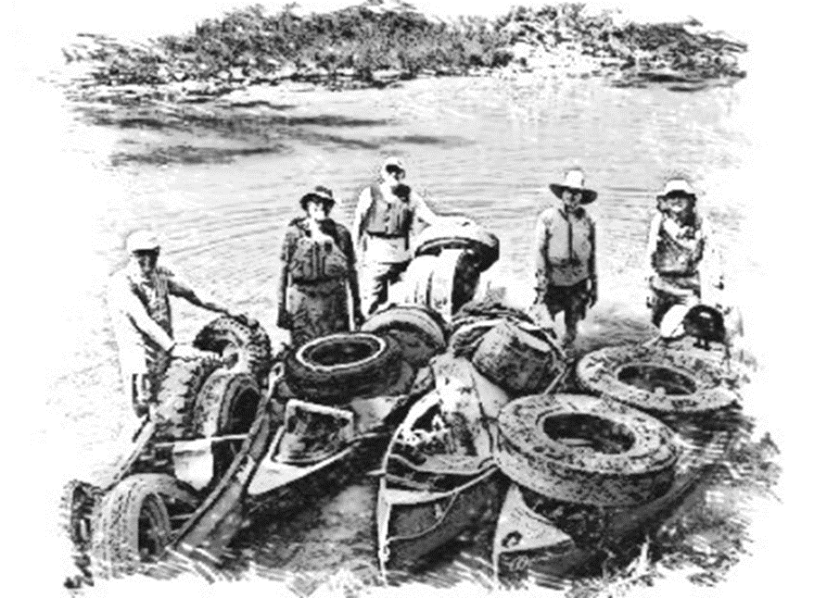

FOMR Safety Committee
River Cleanup Safety Plan

Introduction

The Friends of the Middle River (FOMR) are fortunate to have many members and local volunteers who contribute their time and energy to maintain and improve the quality of the Middle River and its tributaries. One of the most meaningful and visible efforts is through annual trash cleanups in and along the river. Thank you to all who participate in this important project.

River cleanups don’t just happen. They are the result of much planning, investment of time and resources, collaboration with local partners, and, perhaps most importantly, getting the job done in a safe and practical manner.

The FOMR Safety Committee has developed this River Cleanup Safety Plan to assist those who help with our river cleanups. We propose a couple of straightforward, but important organizational concepts. First, there is an overall Coordinator for FOMR river cleanups. This individual leads the cleanup and oversees the scheduling, allocation of resources, and coordination with our multiple local partners. Second, each group of volunteers working on a given cleanup stretch will be led by a Team Leader. The Team Leader coordinates that team’s scheduling and assigns individual roles and responsibilities and ensures safety practices are employed. Team Leaders will be trained in advance of assigned cleanups by the FOMR Safety Committee. Team leaders will, in turn, provide brief safety, itinerary, and logistics details to the members of their team in a short streamside meeting at the launch point.

This River Cleanup Safety Plan will be made available to all river cleanup volunteers in advance of the actual cleanup dates.

This plan is broken down into the following sections:

- Boat and personal outfitting
- Flotilla Operations
- Pre-float briefing/safety meeting by Team Leader
- Trash Pickup Guidelines
- Documentation and liability forms

FOMR Safety Committee
River Cleanup Safety Plan
- Boat and personal outfitting
  - Boats
    - Items required by law (PFDs, whistle, etc.)
      - Coast Guard approved Life vest (PFDs) for all canoeists and kayakers, must fit snugly so it will not ride up.
      - Each boater is to have a proper whistle, capable of alerting team members in case of an emergency, distress, or to warn of a hazard.
    - Items necessary (painters, bailer, etc.)
      - Every boat that is not self-bailing shall have a bailer attached to the vessel by a length of rope that will keep the bailer in the boat when not in use and long enough to efficiently bail a water-laden boat.
      - A painter (rope) shall be properly attached to the bow and stern of each canoe or kayak. This is used for lining (towing) the boat through shallow water, pulling it ashore, etc. The painter is normally ¾ of the length of the boat and made of polypropylene so it will float.
  - Personal outfitting
    - Footwear, gloves
      - Hard-soled shoes that can get wet – old sneakers, work boots, hiking boots, etc. Due to many sharp hazards and slippery river bottom, we strongly discourage sandals or open-sided shoes. Hip waders with felt soles are the best. If knee or calf-length rubber boots are worn, they will fill up with water and get heavy and hinder mobility.
      - Leather gloves or coated gloves to protect against sharp objects even when gloves are wet.
      - Long pants and at least quarter-length sleeved shirts are encouraged to protect against scrapes. Quick-dry clothing works best; cotton is discouraged. Even during warm months, hypothermia is a possibility when wet. A change of clothing is highly recommended as you will almost certainly be wet and grungy at the end of the cleanup.

    - A hat to protect against sunlight
    - Sunscreen
    - Hand sanitizer
    - Water, snacks
    - Personal meds, as needed; e.g. EpiPen

- Flotilla Operations

- Key roles: Team Leader, Front Runner, Sweep Paddler.
- Team leader should not be Front Runner or Sweep Paddler; concentrate on “admin.” The Team Leader is an experienced river person, provides guidance for the outing, and helps the team avoid risks, rather than just reacting to risk. He/she provides an operational and safety briefing riverside before getting underway.
- The Front Runner should ID both hazards and significant trash and should then STOP and let the rest of the group catch up.
- Sweep Paddler stays behind all team members to be sure no one is left behind and that all are safe.
  - Team Leader will have info about participants’ experience from the signup and will assign roles based on replies. Team leader will select experienced paddlers to be Front Runner and Sweep Paddler. Team Leaders will be encouraged to do this before the day of the cleanup so roles are preassigned, when possible. If necessary, Team Leader will pair paddlers in canoes to try to match novices with an experienced paddler.
    - Nobody gets ahead of Front Runner or behind Sweep Paddler.
    - If Front Runner can't see canoes behind, stop and wait.
    - May need all team members to help in case of accident. Or to load heavy trash.
    - If we can't see you, we can't rescue you.
  - Respect private property along the riverbanks.
  - Load capacities of boats, with cutoff by boat operator or team leader. General guidelines:
    - Six inches freeboard for canoes = at least 6 inches of the boat hull should be above the water surface on all sides.
    - Load height maximum = shoulder height of crew. We need visibility, and cannot be top-heavy. Minimize stuff hanging over the sides. Trim: Boat should remain “level” from front to back and side to side when loaded.
    - Must leave room for the crew to sit in the canoe.
    - Bottom line: If the boat feels unstable, it is overloaded and weight should be redistributed to other boats or left at the edge of the river for another crew if it can be scheduled for the same year.
Keep in mind that wading and pulling a loaded canoe behind you might be OK in shallow, slow water, but is very dangerous in deep or swift water. Better to stay in the boat.

  - Safety equipment needed for each team:
    - Walkie Talkies- Two “FRS” family radio service type for each team.
    - First Aid kits – Kits need to be complete
    - Laminated Maps of assigned cleanup area for the team
    - Whistles – one per person
    - Ropes for painters
    - Bailers
    - Waterproof containers for walkie-talkies and cellphones
  - Medical skills within the team will be asked RIVERSIDE.
  - CPR/rescue: We could frame the question asked at the riverside talk “Who has CPR skills and is willing to do CPR if the situation arises?”
  - Interim access locations on route for emergency exit, if needed. Need to know routes.
- Pre-float briefing/safety meeting by Team Leader

Team Leaders:
- will hold a brief group streamside operational and safety chat with the whole group at the beginning of each trip.
- check that everyone has given an Emergency Contact name and phone number for today on the sign-in form.

Streamside Talk by Team Leader:
  - Anyone with a health condition that could suddenly occur—like seizures, carrying an EpiPen for a serious known allergy, heart condition, etc.—we encourage you to inform the Team Leader (me) so we know what is happening to you if something unexpected occurs.
  - I am the Team Leader. The assigned Front Runner today is ________________ The assigned Sweeper is ________________. Stay between these two people. Aim to keep the whole group tight enough that everyone can hear anyone’s whistle and see The Front Runner or the Sweep Paddler.
  - Remember, the Team Leader (me) will determine when a boat is too full to take on more trash but you don’t have to wait for me to tell you. Any of you can decide at any time before I do that you feel you have reached your safe limit. We may have to leave some trash for another day and that’s okay.
  - The Sweeper will be carrying a first aid kit. Is anyone else carrying a kit?
  - It is hard to hear voices over river noise. Blow Your Whistle if You Need Help. Whistles will be loaned to anyone who needs one.
  - With a show of hands,
    - Is anyone here a medical doctor?
    - Who has first aid or wilderness first aid skills?
    - Who here knows CPR and is willing to perform it if the situation arises?
  - I want you to turn to your right and check the PDF of the person next to you to make sure it is snug enough. You should not be able to pull it upwards.
  - Check that the person to your right has a whistle attached to them.

  - Other issues (just highlights streamside as reminders):
    - Key “Flotilla Operations” bullets and discussion and assessment of skills of those in the group, and pairing for safety
    - Review of trash pickup guidelines and safety measures
    - Review of boat and personal outfitting expectations

- Trash Pickup Guidelines
  - Be reasonable and practical.
    - No heroes. Our first priority is safety. Second priority is removal of trash.
  - Safe boat capacities
    - Do not overload boats to the point where boat control is compromised.
    - Heavier objects should be put in the floor of the boat and in the center to keep the center of gravity low and to make the boat less tippy.
    - Trash should not interfere with paddler’s space needed for normal boat operation and control.
  - Potential dangers
    - Swift current can be an increased challenge when a boat is heavily loaded. It also makes boat entry and exit tricky when picking up trash. A stability stick or hiking pole is always helpful if you are wading in the river. The river is full of slippery rocks. Even a canoe paddle can be used for this purpose.
    - Deep water makes trash collection more difficult and is particularly challenging when exiting or entering your boat. If the depth is too deep to wade safely or item is too heavy or deep to safely remove, just leave it, but make note of it.
    - Steep, slippery river banks with rocks, roots, and mud are challenging. When possible, use grabbers or other tools to increase your reach. Also, a walking stick or wading staff can assist with balance along the banks.
    - Bees, hornets, poison ivy, and stinging nettle are all hazardous. If you don’t know if a plant is hazardous, ask a fellow team member if they can ID it.
    - Lifting concerns (remember, no heroes). Everyone wants to remove the “trophy” trash from the river, but only do so if it can be lifted and handled safely. When lifting heavy objects, remember to use your knees, keeping your back straight and lifting with your legs. Work as a team on those big objects, not solo heroes. Pry tires out with tools instead of pulling them out by hand when they are full of mud.
    - Sharp, rusty metal. Nails. Glass, etc. Assume that anything you pick up from the river or the banks has a sharp or pointed edge. Inspect the item first. Use grabbers or a hoe or another tool when possible. And use good gloves.
    - POTENTIAL DANGEROUS MATERIALS, MEDICAL WASTE, AND DRUGS. There is always the possibility that items can contain dangerous chemicals, drugs, or other hazardous materials. If a capped bottle contains liquid, leave it capped and place it in the trash bag and boat gently. Again, wear gloves when handling. Do not handle any suspected drug materials. Mark them with flagging tape and report to the Team Leader.
  - Tools that are helpful
    - Gloves. Gloves are a must. Heavy gloves may be uncomfortable in summer, but they increase your safety tremendously. Light leather work gloves, or vinyl coated (on palms and fingers) fabric gloves are better than plain cotton gloves.
    - Grabbers with a squeeze-grip handle can extend your reach by about 30 inches and help your hands safe, clean and dry.
    - Rake? Garden Hoe? Pry Bar? The Dave Mangun Gnarly Tire Tool? All of these tools can help excavate and lift trash from the streambed and should be used for their leverage and safety attributes.
Sign-In and Hazard Acknowledgement
Cleanup Date:_______________________________________________________
Team Leader:________________________________________________________
River Section:________________________________________________________
Participants may encounter the following hazards during today’s cleanup, including but not limited to:
- Deep or fast-moving water
- Cold water or air temperatures
- Sudden boat capsize
- Unseen sharp objects under water, medical waste or other toxic hazards
- Uneven footing, falling or foot entrapment
- Non-existent cell service or delayed emergency response
- Sudden dangerous weather conditions
If you have a health condition that could suddenly occur—like seizures, serious allergy, EpiPen, heart condition, etc.—we encourage you to inform the Team Leader, Front-Runner and/or Sweeper so we know what is happening to you if something unexpected occurs.

Your Name | Your Emergency Contact’s Name | Their Phone Number
Cleanup Liability Release
Filling out and submitting the following information acts as a signature agreeing to the release of liability as well as signs you up to participate in the Cleanup.
I am volunteering for the Friends of the Middle River Cleanup. As a volunteer, I acknowledge I will not be paid for my services, I may not be covered by any medical or other insurance of the organization(s) involved in the Cleanup, and I will not be eligible for any Workers Compensation benefits.
I and anyone else claiming through me, will not make a claim against 1) Friends of the Middle River, 2) any of its affiliated and partner organizations, 3) their officers or directors collectively or individually, 4) the suppliers of any materials or equipment that is used during the project, or 5) any of the other volunteer workers, for injury or death to me or damage to my property, arising from my participation. This release is intended to be broad in its effect.
I agree to accept any and all risks of injury, illness, infection, or death in connection with my participation in volunteering. I have carefully read this assumption of risk and general liability release agreement, and I fully understand its contents. I am aware that this release of liability is a legal contract between me and the Friends of the Middle River and that it affects my legal rights.
I give permission for my (or my child’s) name, voice, and photographic likeness to be used by the Friends of the Middle River, reporters, journalists or photographers employed by news media. I further consent to the unrestricted use by Friends of the Middle River and/or person(s) authorized by them of any visual or audio media of me and/or my children by the Friends of the Middle River, in perpetuity. I will make no monetary or other claim against the Friends of the Middle River for the use of the media.
I am signing this document of my own free will. Filling out and submitting the following information acts as a signature to this release of liability.
Name, printed: _________________________________________________

Name, signed: _________________________________________________

Date: ________________________________________________________

Phone: _______________________________________________________
Self-Assessment to be a part of the Clean Up Sign Up Form
Please self-assess the skills for the person you are signing up. Check ALL that apply.
I or the minor I am signing up for:
___ Know the difference between Class 1, Class 2, and Class 3 rapids
___ Have never paddled on a river
___ Have kayaked rivers more than 20 times
___ Have canoed rivers more than 20 times
___ Am competent and comfortable paddling Class 2 rivers
___ Am able to walk on uneven, slippery rocks
___ Am able to climb in and out of boats multiple times with adequate strength and balance
___ Can swim
___ Can swim 100 feet (no PFD) in a swimming pool without stopping using any stroke
___ Am competent swimming in Class 2 rapids, with a life vest on, of course
___ Have trained in river rescue skills

Name: _________________________

Date: __________________________

